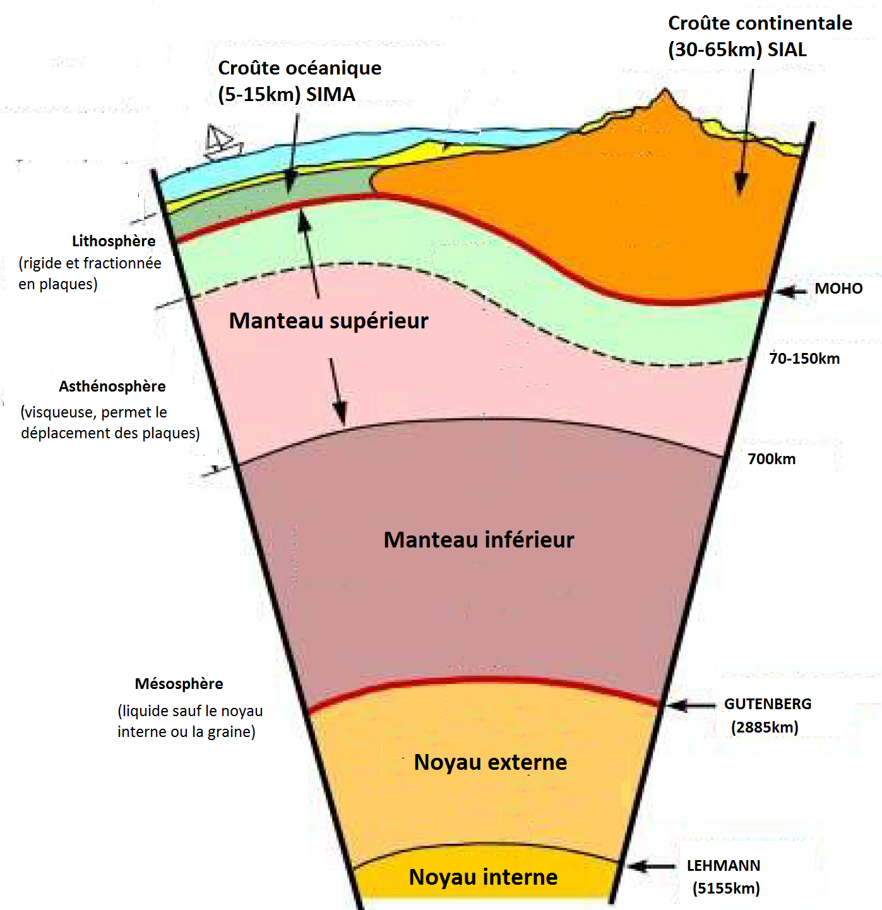
DOCUMENT 2…………………………………………………………………………………………………………………………………

Source : Manuel Géographie, 2nde, Fernand Nathan
……………………………………………………………………………………………………………………
DOCUMENT 2………………………………………………………………………………………………….

Source : Manuel Géographie, 2nde, Fernand Nathan

