Collège Moderne Boniérédougou Année scolaire : 2018 - 2019
Professeur : Niveau : Tle
DOCUMENT 1 :………………………………………………………………………………………………………………………………………………….

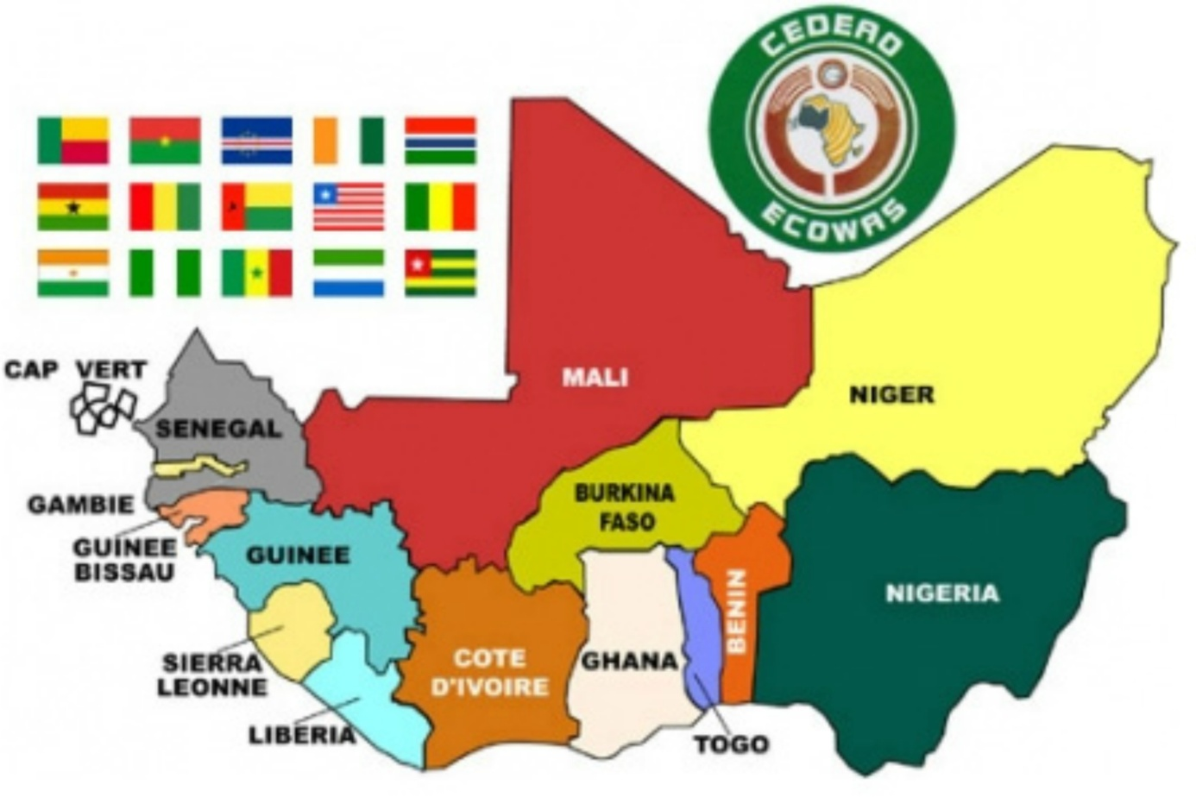
Source :https://images.search.yahoo.com/yhs/search?p=la+carte+des+pays+membres+de+la+cedeao+2018&fr=yhsavgfh_lsonswrow&hspart=avg&hsimp=yhsfh_lsonswrow&imgurl=https%3A%2F%2Ffrstatic.zdn.net%2Ffiles%2Fd0d%2Ff23055c6dc63cd078a2d7ad8fb12d18c.jpg#id=4&iurl=https%3A%2F%2Fwww.euractiv.com%2Fwpcontent%2Fuploads%2Fsites%2F2%2F2014%2F03%2Fecowas_map.jpeg&action=click consulté le 20/04/19 à 09h27mn.

